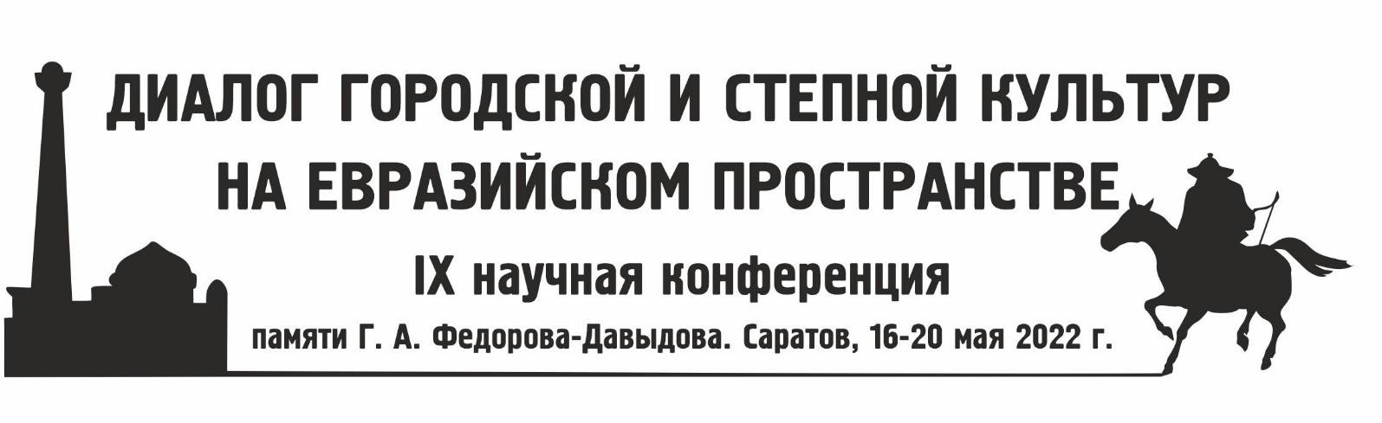

Dear colleagues!
We are glad to announce that the 9th Scientific Conference dedicated to the memory of G.A. Fedorov-Davydov has been scheduled to be held on May 16-20, 2022. Venue: Saratov, “Russia - My History” Historical Park (Shelkovichnaya str., building 19).
The issues related to the archaeology of the Golden Horde and other states formed by the Mongols, as well as the adjacent territories, are planned to be discussed at the conference. The participants are welcome to present analytical reports summarizing the results of long-term studies.
The papers are planned to be published before the start of the conference in the Archaeology of the Eurasian Steppes international peer-reviewed scientific journal. For manuscript preparation guidelines, ref. http://evrazstep.ru/index.php/aes/author_guidelines
We kindly ask you to submit an application for participation in using the attached form before December 15, 2021 to the following address: Fdkonf@yandex.ru
Publication materials should be submitted before February 3, 2022. The organizing committee will provide more detailed information in upcoming letters.
We are kindly asking you to most efficiently distribute the details of this conference among any interested colleagues.
We are looking forward to seeing you in Saratov!

Best regards,
Conference Organizing Committee.

